Proceedings of 28th International Scientific Conference. Transport Means 2025. Italic 12pt
(Single space 12pt)

Example of Scientific Manuscript Bold 14pt (Word Heading 2 style)
(Single space 12pt)

P. Kilkauskas¹, S. Daliulionis² Bold 12pt (Word Heading 3 style)
(Single space 12pt)

¹Kaunas University of Technology, Donelaičio 17, 44239, Kaunas, Lithuania, E-mail: kilkauskas@ktu.lt 10pt

²Kaunas University of Technology, Vytauto 3, 44354, Kaunas, Lithuania, E-mail: daliulionis@ktu.lt
(Single space 3pt)
https://doi.org/10.5755/e01.2351-7034.2025.P
(Single space 10pt)

Abstract 10pt (Word Heading 5 style)
(Single space 10pt)
The abstract must be written using a 10-point “Times New Roman” font without first line indentation. Abstract must reflect the content of the paper faithfully. It should summarize major aspects of the article and provide sufficient information to judge the nature and significance of the topic, the adequacy of the investigative strategy, the nature of the results, and the conclusions. 10pt
KEY WORDS: list of key words; written in italics 10pt
(Single space 10pt)

1. Introduction 10pt (Word Heading 5 style)
(Single space 10pt)
The article should be prepared using Microsoft Word. The font for English text should be “Times New Roman”. The manuscript should be written using the A4 format page with the following margins: top – 2.0 cm, bottom – 2.0 cm, left – 2.0 cm, right – 2.0 cm, paragraph indent 1.0 cm, single line spacing. A page setup example is given in Fig. 1 and Fig. 2.
(Single space 10pt)
10pt Table 1
Font style and size 10pt
(Single space 5pt)
Part of article | Font style | Size, pt
Title | Bold | 14
Authors | Bold | 12
Organization address | Italic | 10
Abstract | Regular | 10
Key words | Italic | 10
Other text | Regular | 10
References | Regular | 10
Text in the table | Regular | 10 or 9
(Single space 10pt)
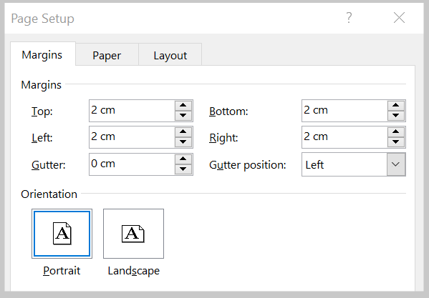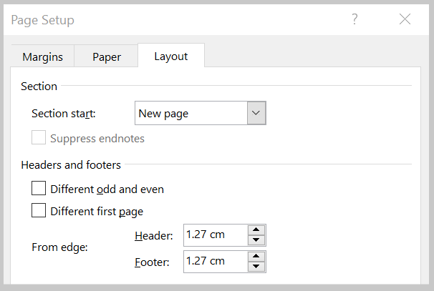
(Single space 5pt)
Fig. 1 Page margins setup: top – 2.0 cm; bottom – 2.0 cm; left – 2.0 cm; right – 2.0 cm 10pt | Fig. 2 Page size setup 10pt
(Single space 10pt)

2. More Information (Word Heading 5 style)
(Single space 10pt)

2.1. About Figures and Tables (Word Heading 5 style)
(Single space 10pt)
For figures:
- All figures will be printed in black and white; (Word Bullets style)
- Coloured figures will be seen only in the PDF format;
- All figures must have consecutive numbering and captions;
- Centre alignment without indentation should be used for figures;
- Between the figure and the caption there should be a 5 points space;
- From caption to text – 10 points.
Tables are created with the word processing program. Figure captions and table titles are only in the English language. Figures and tables are numbered with Arabic numerals. In the text a figure or table is referenced by its number (e.g. in Fig. 1, in Table 1, etc.). The width of a figure or table can not exceed 17 cm.
- All tables should be consecutively numbered and captioned. From text to the number of the table there should be a single space of 10 points. There should be no space between the table number and table caption. Table number should be aligned with the right side of the table. (Word Numbering style)
- All sources in the article must be cited [1]. Multiple sources in a citation must either be separated by a comma (if two sources or not consecutive) [3, 4] or separated by a dash (if multiple consecutive sources) [5-9].
(Single space 10pt)

2.2. About Equations (Word Heading 5 style)
(Single space 10pt)
Equations are numbered with Arabic numerals in parenthesis. In the text an equation is referenced by its number in parenthesis - "... from Eq. (1) follows ...". Some examples of equations are given below.
For the adjustments of sizes and styles see Fig. 3, a and b. Font style is the same as for the text – “Times New Roman”. For equation formatting in the text use Word Equation style (tab stop positions: 8.3 (Center), 17 (Right)).
Equations should be editable and not appear in a picture format.
(Single space 10pt)
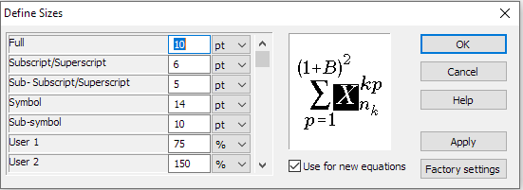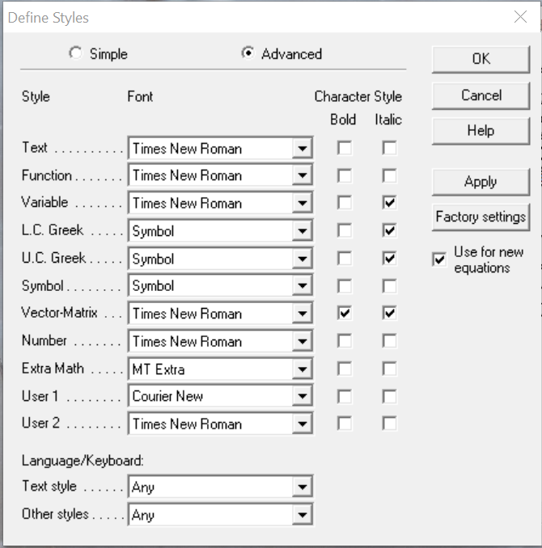
(Single space 5pt)
a 10pt b
(Single space 5pt)
Fig. 3 Settings for equation: a – font size; b – text font 10pt
(Single space 10pt)
Bellow you can see some equations Eq. (1) – Eq. (4) formatting examples.

(1)
Equation style:
Tab stop positions: 8.3 (Center), 17 (Right)
(Single space 10pt)
where $P'$ – supplied pressure; b – length of the armor fiber per muscle length; n – the number of the thread windings per muscle length; $θ$ – the angle between a braided thread and the actuator’s longitudinal axis.
Taking into account $L=\text{cos}θ$ [1] and the values of the actuator-generated force, length at two points on the curve representing force – contraction relationship [3] at the same pressure $P'=\text{const}$ ( and ), factors n and b can be expressed as fallows.
The operation of a suspension was simulated using the parameters equivalents to VW Golf car. These equivalent parameters are given in Table 1.
(Single space 10pt)
; (2)
(Single space 5pt)
; (3)
(Single space 5pt)
. (4)
(Single space 10pt)

3. Conclusions (Word Heading 5 style)
(Single space 10pt)
Write each conclusion in a new paragraph. Do not number the conclusions.
Self-citations of authors - no more than 3 papers. Citations of conference proceedings "Transport Means" papers – no more than 1 paper.
Each paper must be no more than 6 pages. Extra pages will be charged 50 EUR per page.
The publication fee for paper is payable only if a paper is accepted for publication.
Cancellations received before 1st August 2021 will receive a 75% refund. No refund will be granted for cancellations received from 2nd August 2021.
(Single space 10pt)

Acknowledgement (Word Heading 5 style)
(Single space 10pt)
Acknowledgement should use the same formatting as body text. No pictures should be included.
(Single space 10pt)

References (Word Heading 5 style)
(Single space 10pt)
- Mitsche, M. 1987. Theory of Vehicle. Dynamic of Vehicle. Tom 2 Vibrations, Warsaw: Publishing of Communications, 266 p.
- Reimpell, J. 1997. Podwozia Samochodow: Podstawy Konstrukcji. Warszava: Wydawnictwa Komunikacji i Łączności, 411 s. (in Polish).
- Rutka, A.; Sapragonas J. 2002. Investigation of car suspension model, Mechanika 1(33): 41-48.
- Swayze, J.L.; Bachrach, B.I.; Shankar, S.R. 1999. Suspension force optimization using quarter-car model with elastomeric elements, Proceedings of Noise and Vibration Conference, Michigan 2: 785-795.
- All about the Toyota Prius [online cit.: 2014-05-22]. Available from: http://techno-fandom.org/~hobbit/cars/
training/prius02.htmlg
- Comparison of Otto and Atkinson cycles [online cit.: 2014-05-22]. Available from: http://www.searchautoparts.
com/motorage/training/old-engine-designs-are-new-again
- Pitla, S.K.; Luck, J.D.; Werner, J.; Lin, N. 2016. In-field Fuel Use and Load States of Agricultural Field Machinery, Computers and Electronics in Agriculture 121: 290-300.
- Krawiec, P. 2017. Analysis of selected dynamic features of a two-wheeled transmission system, Journal of Theoretical and Applied Mechanics 55(2): 461-467.

